Alignment of LeuT and BetP.

Beside being both symporter proteins, BetP and LeuT also share the inverted repeat topology. In the HOMEP2012 database they were identified as belonging to the same family of proteins. They constitute an excellent example of two trans-membrane proteins belonging to the same family while sharing hardly any similarity on a sequence level.

We compared the pair-wise alignments without anchors (Fig 1, left) with the one using anchors, derived from the alignment of two multiple sequences alignments (Fig 1, right), created with the AlignMe server. For the applied workflow for deriving anchors see Fig 7. The alignments show clear differences, indicating that for these highly challenging cases a simple pairwise alignment will not suffice to get a proper alignment.

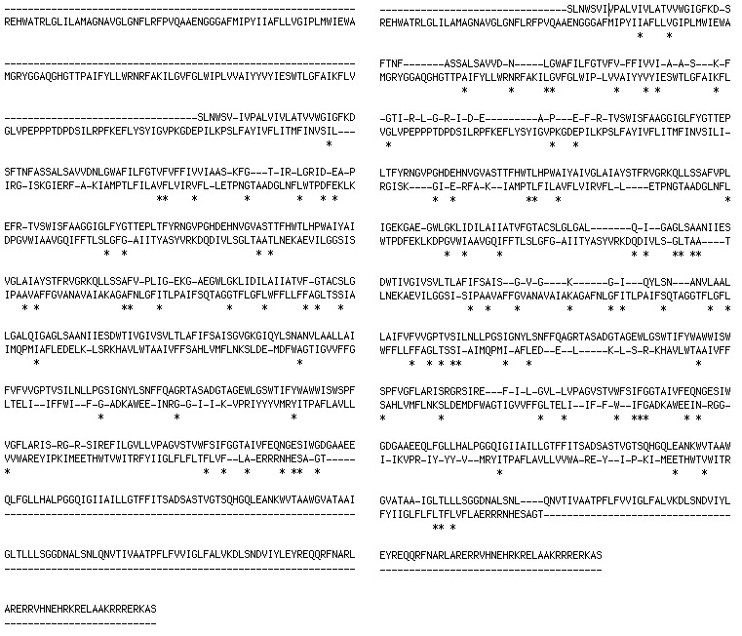
Fig 1: Pairwise alignment of BetP (top sequence) with LeuT (lower sequence) with (right side) and without (left side) anchors.

The improvement due to the anchors becomes more obvious when looking at the alignment of the profiles. Figure 2 shows four profiles for the alignment without anchors, Figure 3 the profiles for the alignment using the anchors.

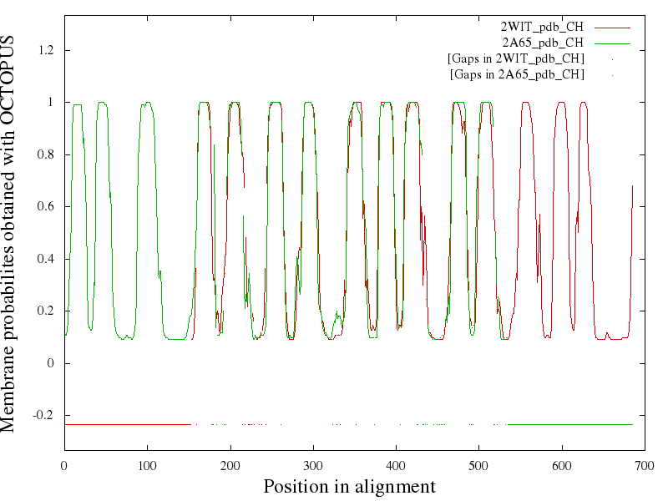
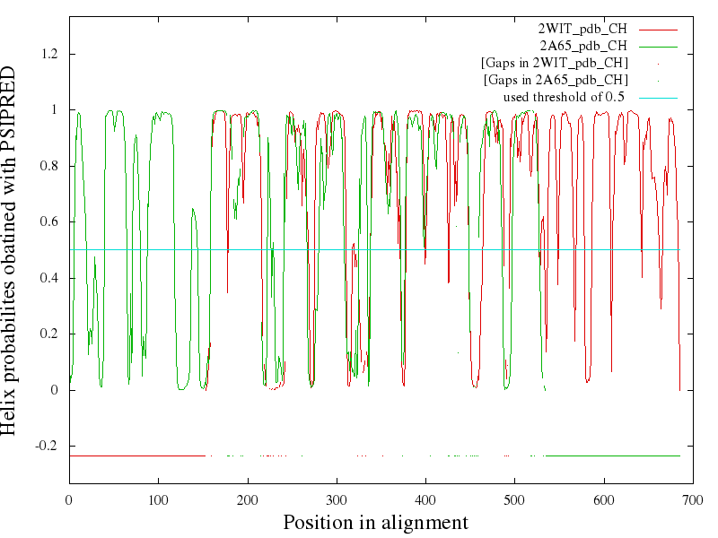

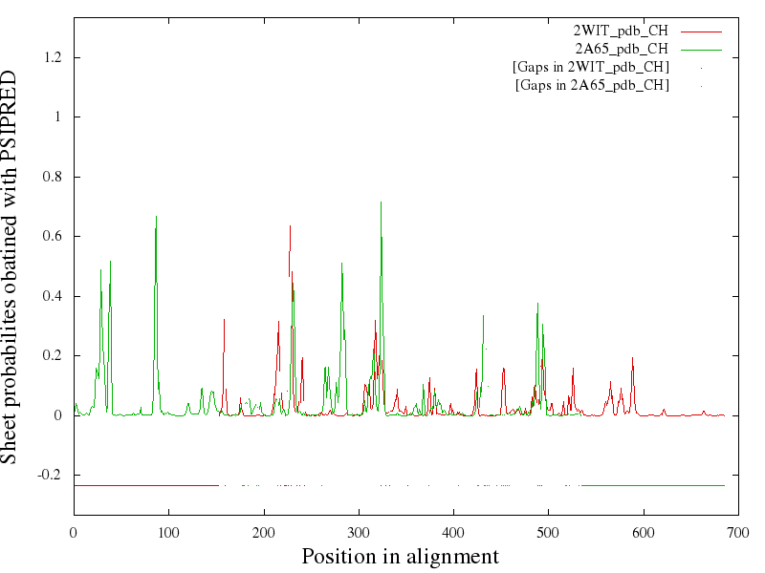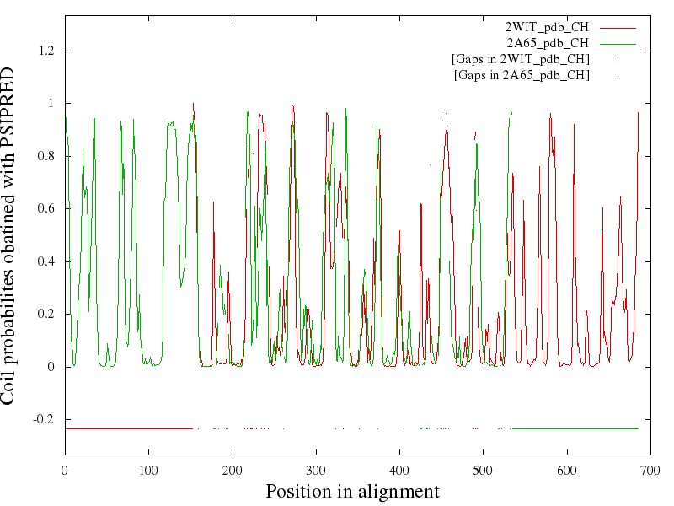
Fig 2: Profiles from the alignment of BetP (red) and LeuT (green) without anchors. On top are aligned transmembrane predictions, then follow three for the secondary structure prediction (helix, sheet, coil).

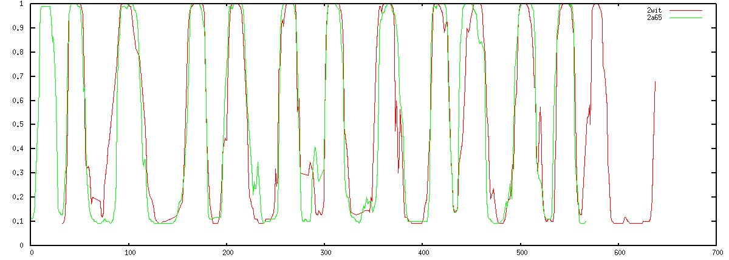
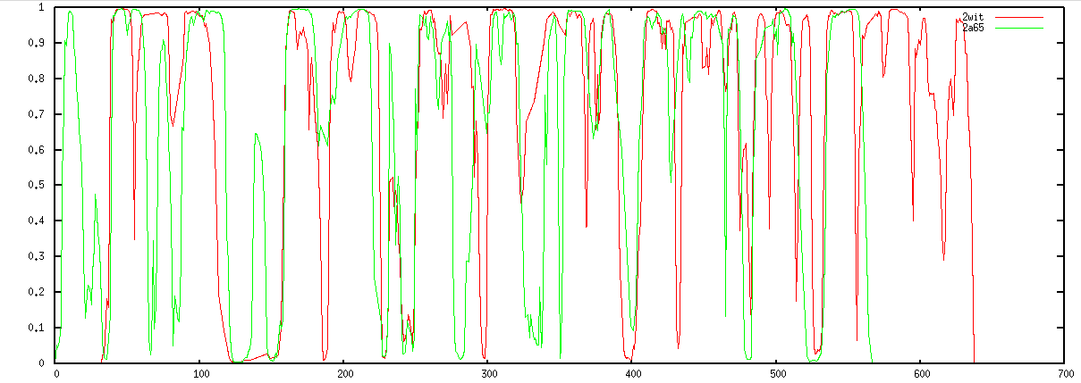
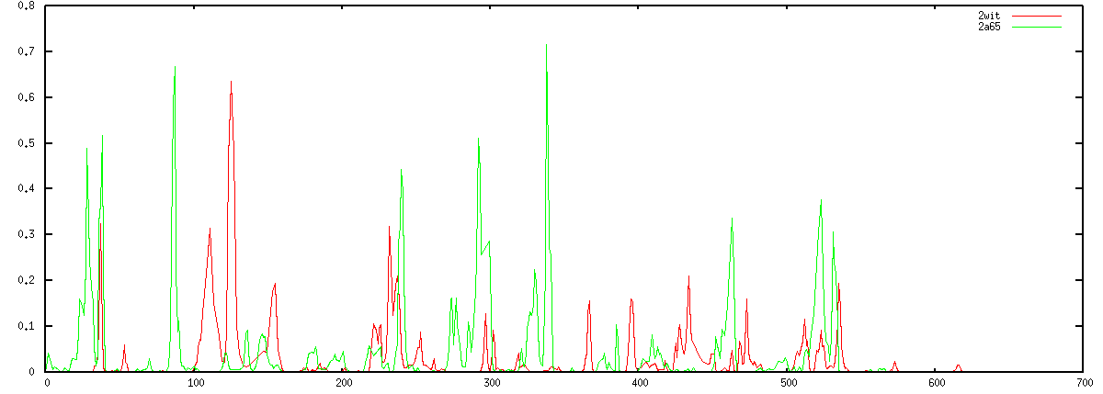
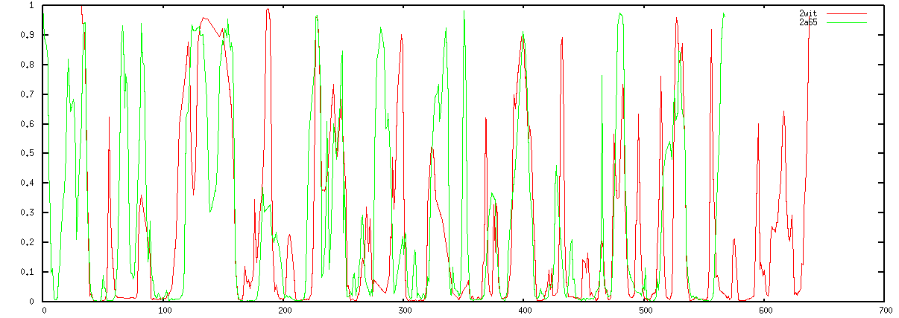

Fig 3: Profiles from the alignment of BetP (red) and LeuT (green) using anchors. On top are aligned transmembrane predictions, then follow three for the secondary structure prediction (helix, sheet, coil).

The alignments differ significantly and seem greatly improved due to the anchors.

The anchors were derived as follows: for both LeuT and BetP homologous sequences were collected using PSI-BLAST and a multiple sequence alignment was created using T-COFFEE for both individually. The two MSAs were used as input for the AlignMe server PP mode. The server creates an averaged hydrophobicity profile for each of the MSAs and aligns these. In a second step a consensus sequence is created for which the alignment is shown in Fig 4. In Fig 5

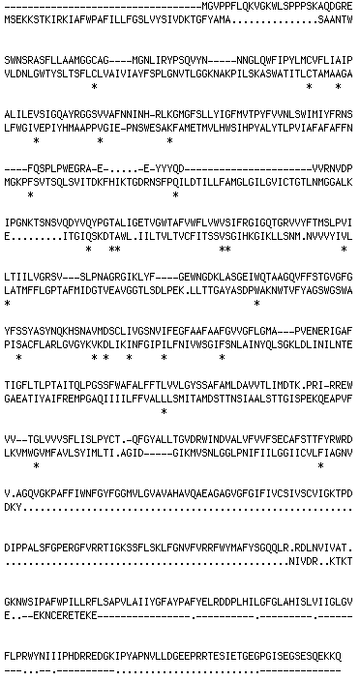

Fig 4: the alignment of the two MSAs mapped back onto a consensus sequence

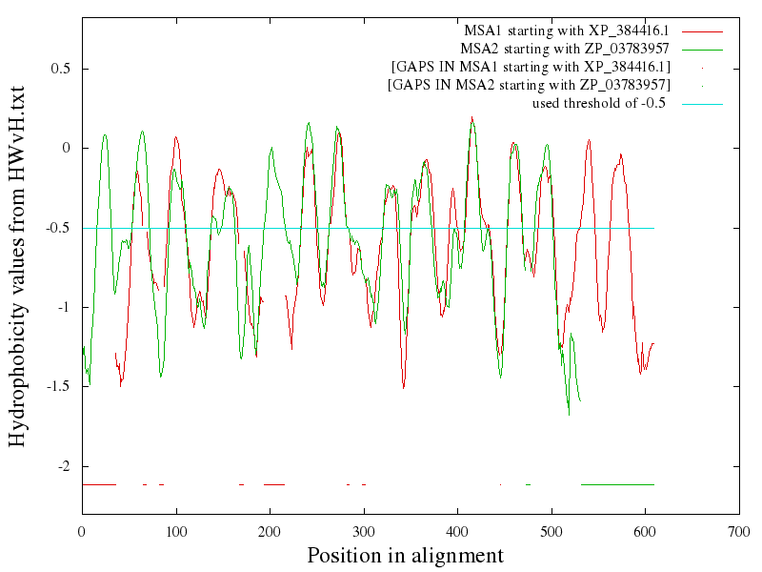

Fig 5: the aligned averaged hydrophobicity profiles of the MSAs of BetP (green) and LeuT (red).

From Fig 5 anchors were derived manually at residues (54,99), (201,273), (336,415). Note that these are residue IDs, not positions from Fig 5.

 |  |  |  | -1 | -1 | -1
 | 0 |  |  | -1 | -1 | -1
 |  |  |  | -1 | -1 | -1
 |  |  |  | -1 | -1 | -1
-1 | -1 | -1 | -1 | 0
-1 | -1 | -1 | -1 |  |  | 0
-1 | -1 | -1 | -1

Fig 6: a sketch of a small anchor matrix. The weight of the anchor is set arbitrarily to 1 in this example. The green zero indicates the anchor position.

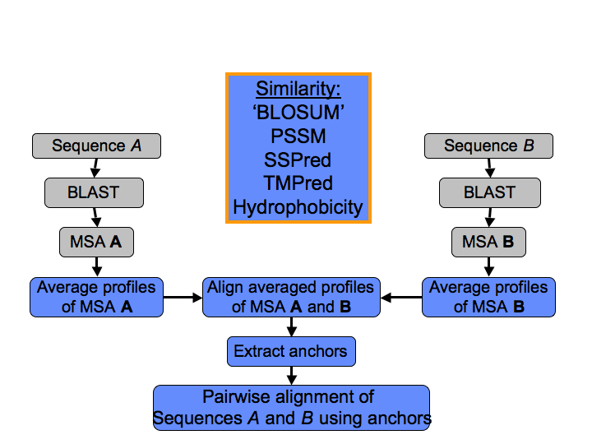

Fig 7: The workflow of the alignment strategy for proteins sharing hardly any similarity on a sequence level.

